Chapter 11, Solution 46.

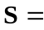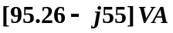

Apparent power =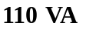
Real power =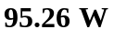
Reactive power =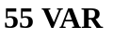
pf is leading because current leads voltage

- 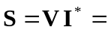
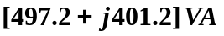

Apparent power =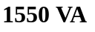
Real power =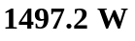
Reactive power =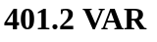
pf is lagging because current lags voltage

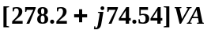

Apparent power =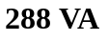
Real power =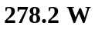
Reactive power =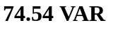
pf is lagging because current lags voltage

[961.7 – j961.7] VA

Apparent power =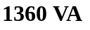
Real power = 961.7 W
Reactive power =
pf is leading because current leads voltage

